**Customer Churn Analysis for NexWave**

**Using Data-Driven Insights to Enhance Customer Retention and Value**

Company: NexWave Communications

Industry: Telecommunications

Project Focus: Data Analysis and Visualization of Customer Churn Drivers

**Prepared By: -**

**Shashank Singh**

**Tool Used: -** Tableau

**Background: -**

In the highly competitive telecom industry, customer attrition—or churn—is a critical issue that directly impacts the profitability and sustainability of a company. "NexWave," a leading telecom provider, is facing challenges in retaining customers amid growing competition, changing customer preferences, and technological advancements. Understanding the reasons behind customer churn is essential for NexWave to implement effective retention strategies and optimize customer lifetime value (CLV).

Customer attrition refers to the loss of subscribers over a period, which can occur due to dissatisfaction with services, better offerings from competitors, or a mismatch between customer expectations and company performance. Companies like NexWave need to reduce churn by identifying the factors driving customers away and addressing them with data-driven decisions. It is always better to retain existing customers rather than attracting new customers.

Customer churn analysis involves a deep dive into behavioral patterns, demographics, and service usage data to identify key predictors of churn. The analysis typically relies on historical data, including customer profiles, service usage patterns, contract details, and interactions with customer service. The aim is to develop predictive models that classify customers as likely to churn or stay based on certain attributes.

For this project, Tableau is used to visualize the insights, providing a clear and interactive representation of churn drivers. Visual tools like Tableau can transform complex datasets into digestible dashboards, allowing decision-makers at NexWave to monitor trends, identify at-risk customers, and evaluate the effectiveness of retention campaigns in real-time.

General factors that influence customer churn in the telecom industry include:

Service Quality: Poor network performance, dropped calls, and slow data speeds can frustrate customers, prompting them to switch to competitors.

Billing Issues: Complicated billing procedures or unexpected charges are common triggers for customer dissatisfaction.

Contract Type: Customers on month-to-month contracts often have a higher likelihood of churning compared to those on long-term contracts.

Customer Support: Poor experiences with customer service, such as long wait times or unresolved issues, can drive customers to leave.

Competition: Competitors offering better deals, promotions, or technological advantages can entice customers away from NexWave.

In this project, the objective is to identify what factors impact customer churn using customer data. By leveraging Tableau's visualization capabilities, the analysis aims to provide NexWave with actionable insights that help reduce churn and increase customer loyalty.

**Column Description: -**

The csv file contains 29 columns and has records for 6687 customers. Following is a brief description of all the columns.

Customer ID – The unique ID that identifies a customer

Churn Label – Contain “yes” or “No” to indicate if a customer has churned (i.e. stopped using NexWave’s services)

Churn Reason – The particular reason why the customer ended the contract

Churn Category – Groups multiple churn reasons together for analysis purposes

Gender – The gender of the customer, indicated by “Male”, “Female” or “Prefer not to say”

Under 30 – Indicated if the customer is under the age of 30 with “Yes” or “No”

Senior – Indicates if the customer is above the age of 65 with “Yes” or “No”

Age – The age of the customer

Contract Type – There are 3 types of contract, “Month to Month”, “One Year” or “Two Year”

Payment Method – Preferred payment method of the customer indicated with “Credit Card”, “Direct Debit” or “Paper Check”

State – The code of US state where the customer lives

Phone Number – Contact number of the customer with which customer has registered

Group – Indicates if the customer is part of a group contract. A group contract offers advantages and is generally cheaper.

No. of customers in the group – this indicates no of customers in the group package, if customer has taken group package

Account Length – The number of months the customer has been with the Company

Local Calls – Amount of calls made by the customer within United States

Intl Calls – Amount of international calls

Intl Mins – The number of minutes spent calling internationally. Intl Active : Indicates if the customer called internationally with a “Yes” or “No”

Intl Plan – Indicates if the customer has a premium plan to call internationally for free with “yes” or “no”. This premium reflects in the amount of the monthly charge

Extra International Charges – Contains the extra charges for international calls for customers who are not on an international plan

Customer Service Calls – The number of calls made to customer service

Avg Monthly GB Download – Contains the average monthly download volume in gigabytes

Unlimited Data Plan – Indicates if the customer has free unlimited download capacity with “yes” or “no”. This is reflected in the amount of the monthly charge

Extra Data Charges – Contains the extra charges for data downloads for customers who are not on an unlimited plan

Monthly Charges – Average of all Monthly Charges to the customer

Total Charges – Sum of all monthly charges

**Findings and Analysis: -**

1. **Calculated the overall churn rate**The first step in any analysis is data check, I want to check for any duplicate rows since it can cause double counting so I created 2 calculated fields to check if there are any duplicate rows. “Number of unique customers” count the distinct customer ids and “Number of Customers” count all the rows that have customer id.

Both counts of customer id are 6687, therefore there are no duplicate rows.  
  
Now we will calculate overall churn rate. We have a column churn label that indicates weather a customer has churned or not but it is not in numerical form, it just shows “yes” for customers who have churned and “no” for those who have not churned, this is not easy to work with so we will create a new column called “Churned” that gives us 1 if customer has churned and 0 if customer remains with us.  
  
For this I have created calculated field “churned” using IF function. Now we have a column which quantifies customer attrition.   
To calculate total number of customers who have left, we will create “Number of Churned Customers” column using SUM function, to add up the “Churned” column which we just created, this will give us total number of customers who have left our company  
  
Total number of churned customers is 1796. We can divide this by total number of customers to get overall churn rate.  
Creating a calculated field “Churn Rate” which divides “Number of Churned Customers” by “Number of Customers”  
  
Churn Rate = (Number of Churned Customers) / (Number of Customers)  
  
**The Overall Churn Rate for NexWave id 26.86%.**

1. **Investigated top reasons for customer attrition**

The next step is to find out top reasons for customer attrition. We have two columns in our dataset which gives us reason for customer attrition. The “Churn Reason Column” gives us the exact reason for attrition and “Churn Category” gives us the main category for attrition i.e. Competitor, Customer Service etc.  
  
To find out top 5 reasons we have created a bar chart that shows Churn reason and what percentage of churned customers had that reason for leaving our company.

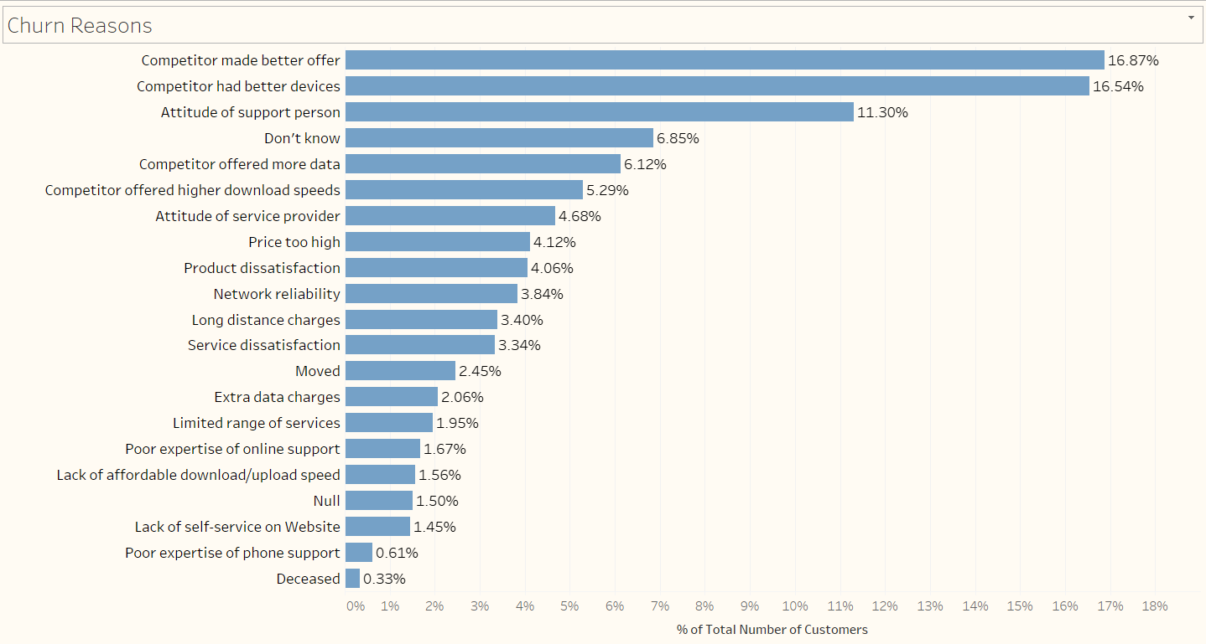

Top 5 reasons are as follows:-  
Competitor made better offer  
competitor had better devices  
Attitude of customer/Technical support person  
Competitor offered more data  
competitor offered higher download speed

1. **Divided Churners into 5 categories**  
     
   There are plenty of churn reasons, so to summarize it is better to divide all the reasons into simpler categories for ease of understanding. The 5 categories are - Attitude of customer support/Technician, Competitor, Price, Dissatisfaction with the service  
     
   The Top 3 categories are Competitors (44.82%), Attitude of the customer support person (15.98%), Dissatisfaction with product or services (15.92%).

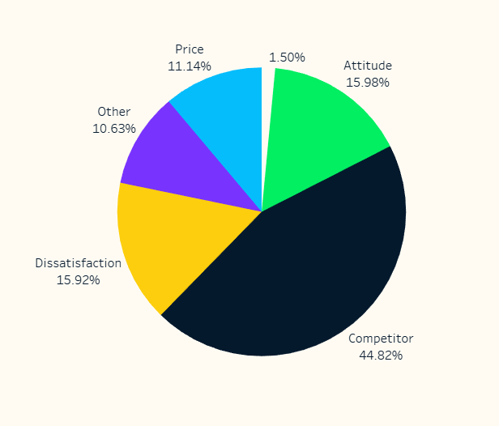

1. **Now we Investigated Churn rate by Location**  
   Since our product and services face different level of competition in different states, it is important to see if churn rate differs by states.  
   We have created a map with color gradient to visualize churn rate for different states  
     
   Most states have churn rate ranging from 20% to 32%, However California is an exception at churn rate of 63.24%.   
     
   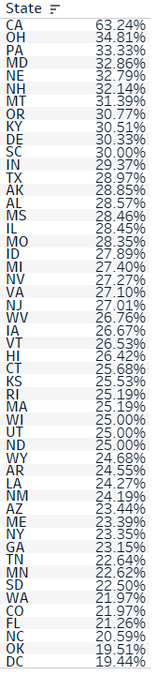

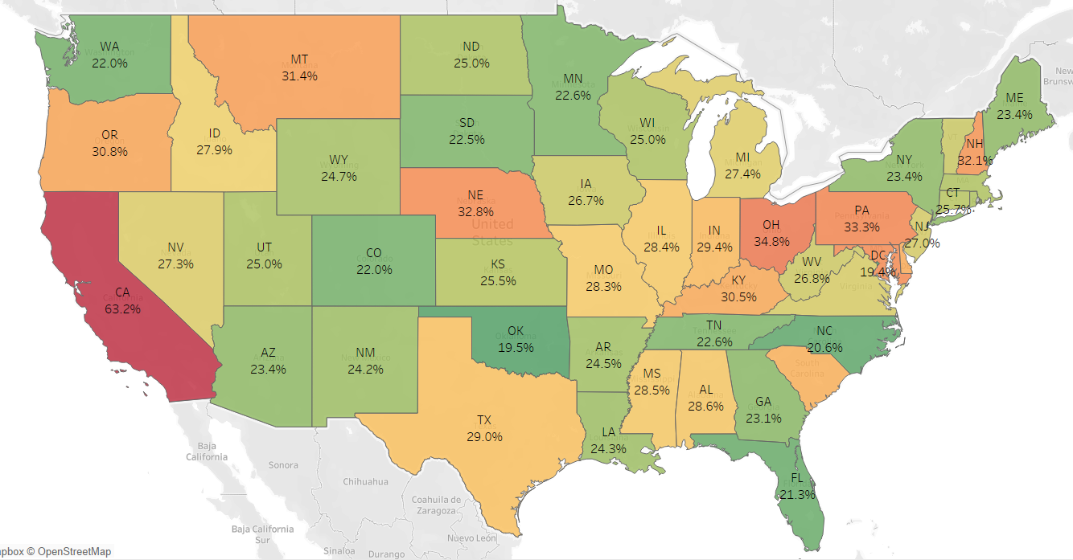

There is another problem with California most states have clearly stated churn category, but in California of all the churned customers about 62.8 % have null as their churn category which means we don’t have churn reason for majority of churners in California.  
  
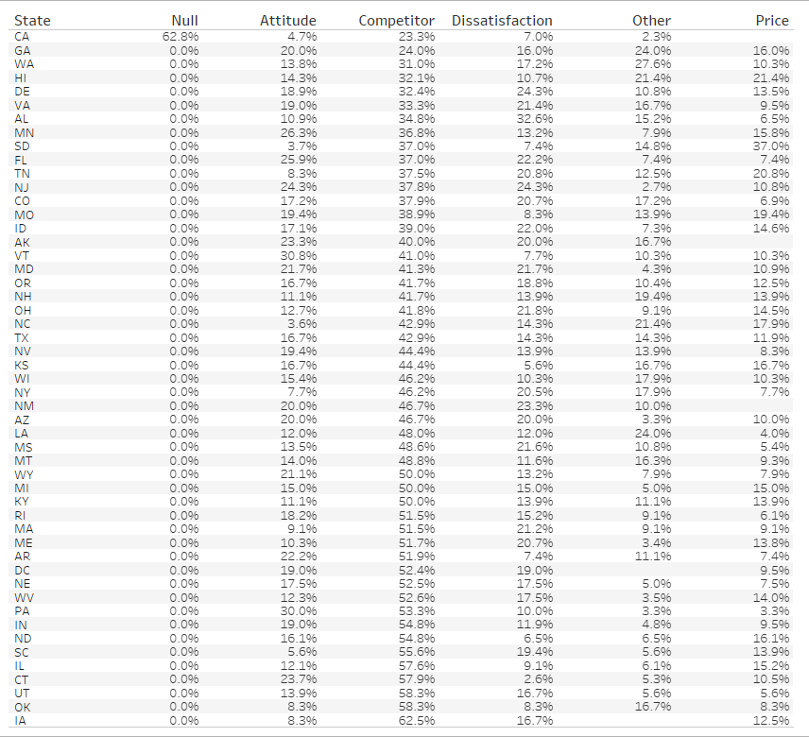

1. **Demographic investigation**  
   Now we will investigate how different demographic factors affect churn rate. First we will see how does age affects churn rate. It is evident from the column chart that from age 60 the churn rate increases rapidly. Overall senior citizens had higher churn rate than the average.

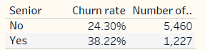

Churn rate for senior citizens is higher than other age groups (38.22% vs 24.30%)

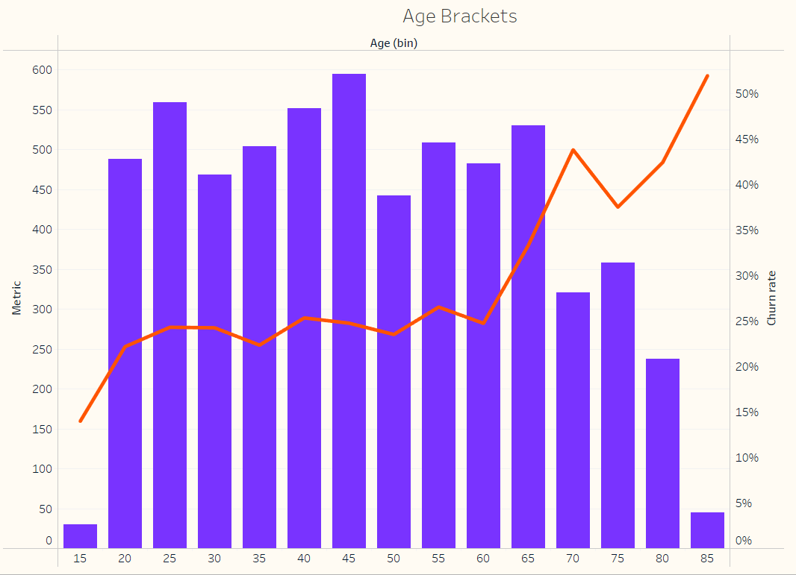

1. **Finding attrition by group Schemes**  
     
   NexWave offers family schemes for those customers who like to take group based schemes which is for more than 1 individual. NexWave offers group contracts to customers from the same household. The advantage for the customers is a discounted rate,while it’s a great way for NexWave to grow it’s customer base, We are curious if churn rate is different for those who take individual scheme vs those who take group schemes.  
   For customers belonging to same household company has provided discount scheme, groups range from size of 2 individuals to 6 individuals.

We have Created a dynamic parameter called “Pick Metric” which shows “Average Monthly Charge”, “Number of Customers”, Number of churned Customers “ and “Average Customer Service Calls”.

Following Combo chart shows churn rate and number of churned customers  
  
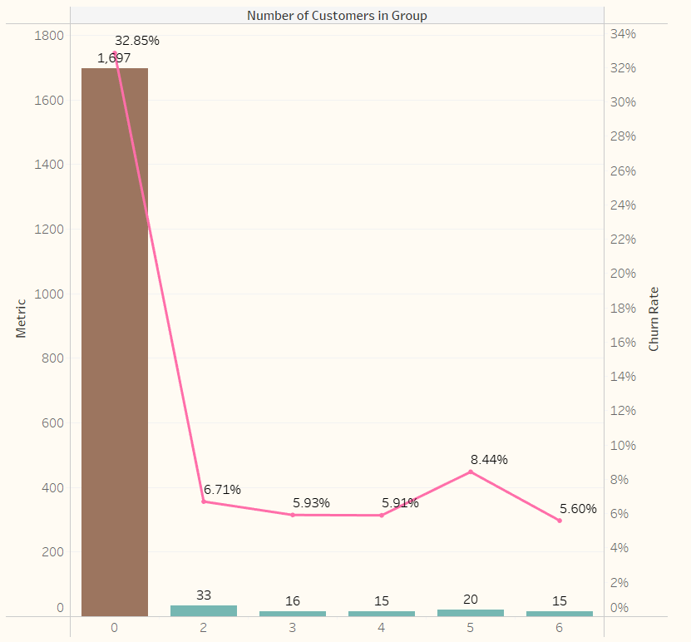

It is clearly visible from the line chart, that customers who are in a group have significantly lower churn rate and column chart shows number of churned customers is much lower for customers who have availed household scheme (grouped scheme).

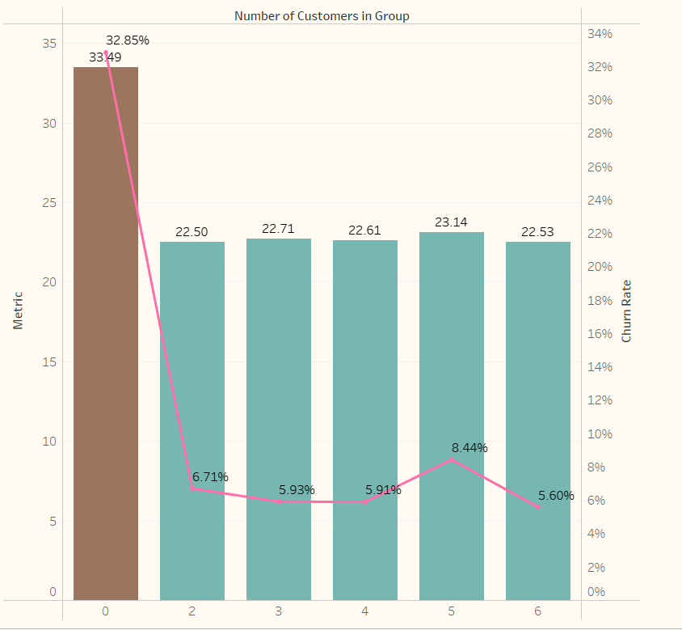

The above chart shows average monthly charge for individual customers and customers who have taken grouped scheme. The average monthly charge for individual customers is about $33.5 and for customer who availed grouped scheme it is $22 - $23. The lower average monthly cost could be one of the reasons why churn rate is lower for customers who take grouped scheme.

Average Monthly charge is higher for customers who do not belong to Group scheme. Also churn rate is significantly higher for customers who are not in a group (32.85% vs (5% to 8%))

Another interesting finding is that customers in grouped scheme also make less service calls which means they face less technical issues, the reason for this is unknown since both type of customers use same internet modem/router and network.

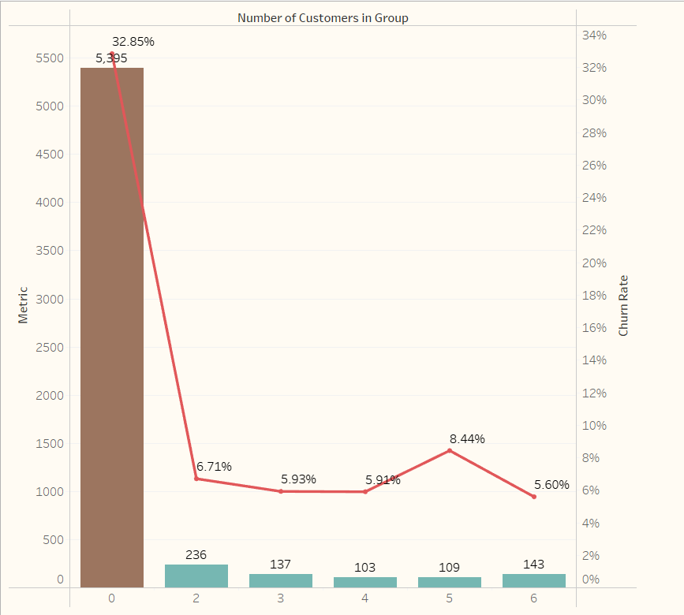

1. **Investigated the role of unlimited data plan and monthly data scheme on churn rate**

Now we will investigate the role of unlimited plan, our hypothesis is that people who are not on unlimited data plan will have more churn rate.  
  
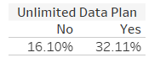

The results are opposite to what we anticipated, customers who do not have unlimited plan actually have lower Churn rate.

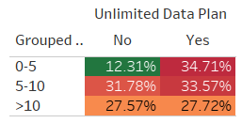

Upon further investigation we find that yes people who do not have unlimited plan have lower churn rate but only for those customers who use less than 5 GB of data in a month.

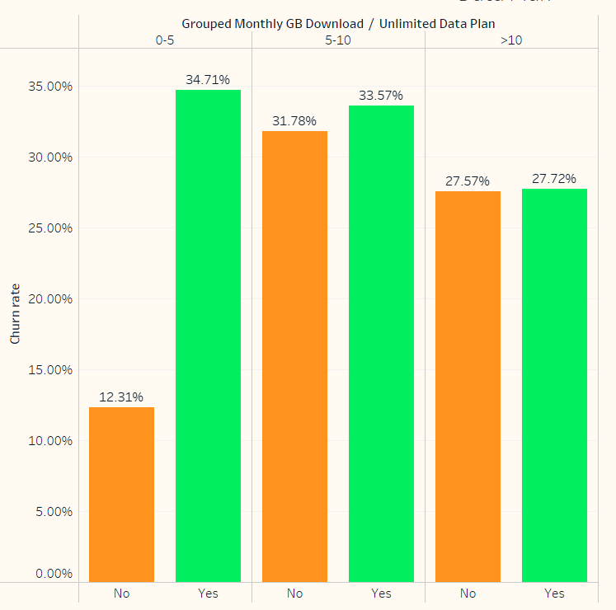

What we find here is really interesting customers who have taken monthly plan for less than 5 GB and those who have not taken unlimited plan have much lower churn rate than all other plans. We should recommend management to unlimited plan for Data plan less than 5GB.

1. **Investigated if churn rate has anything to do with international plan**

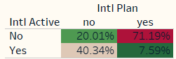

Customers who have taken international plan but are not active have quite high churn rate at 71.2%

We should suggest customers who have purchased international plan but don’t use it, they should downgrade their plan.  
  
Similarly For those customers who are active internationally but do not have international plan have higher churn rate of 40.3%. The conclusion we can derive from this is that customers should take plan which suits their needs. People who are on international plan but are not active should be encourages to downgrade their plan.  
And those customers who are active internationally but don’t have international plan should be offered international plan.

1. **Investigating the impact of payment method, account length and contract type with the churn rate.**

Now we will see the role of customer account duration(i.e. no. of months a customer is buying our services) , contract type and payment method to churn rate.  
There are 3 types of contracts – monthly basis, one year and two year. The customer pays the amount for services in advance for these time periods.  
  
We find that customers who are on monthly basis have the highest churn rate of 51%, only half of customers in monthly contract remain. This could be because customers who take monthly contract are taking it just for trial and if they do not like the product they leave.  
Our Advice to management will be to encourage month to month contract customers to upgrade to yearly contracts.

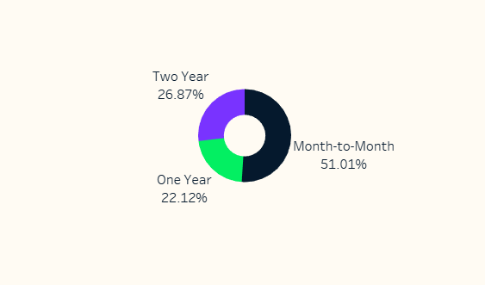

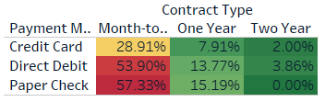

When it comes to payment method the highest churn rate is for paper cheque. This could be because customers who are just taking trial, do not wish to use their debit/credit card.

Now we will plot a scatter graph of customer account length against churn rate.

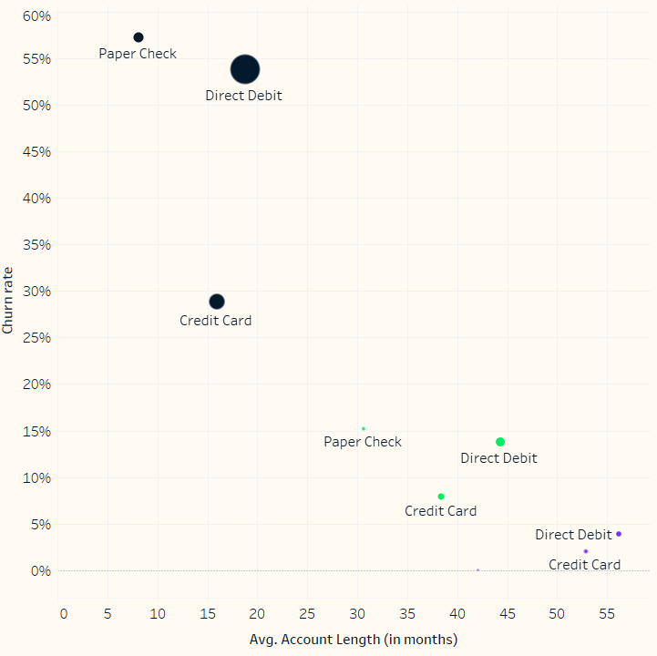

Customers who have stayed with NexWave for at least 30 months have significantly lower churn rate.

**Recommendation for the Management: -**

* Since almost half of the attrition is due to competitors, we need to do market research on our competitors and see what are their products and services and how do they perform against ours.
* Second thing we have to look into is the behavior of our customer support and technician who interacts with the customer, since 16% of the attrition is due to these factors. We cannot control external market factors but we can definitely improve the behavior and working of our employees.
* Third factor responsible for churn is dissatisfaction with the product, so we should upgrade our modem, provide higher speed modem and more data for same price.
* California has the highest churn rate of 63.2% compared to 26.86% average churn rate. Moreover, there is one more problem in California out of all the customers who have churned, for 62.8% we don’t know the reason for leaving. Therefore I would suggest that management should launch a survey for those customers who are leaving in California so that we can first understand the problem and deal with it accordingly.
* When a new customer is buying our services we should always encourage them to take grouped scheme(household scheme) since it is evident that grouped customers churn less and they also make less service calls.
* Unlimited data plan for less than 5 GB of data should be removed.